Delete duplicate Repos from this path

C:\Users\Sohail\Source\Repos

Repos has nothing to do with Project loaded in the VS

It can be done without loading the project by only opening the VS

Make the Blank Folder in the Drive

Git Hub will not create Repo on the Folder having Files

Delete the Same Repo Name if it exist on the Web Site

Settings Tab, in the Last option to Delete the Repo by taking name of Repo

In the Start we will creat blank folder on the Computer and Blank Folder on the

GitHub and Sink them

Open Blank Visual Studio, no project loaded. Git Hub remain connected across projects, once connected.

Manage Connection will open all Repo list in the VS

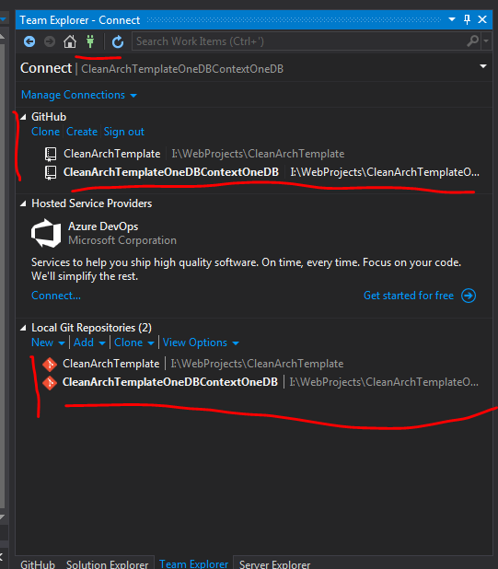

Add new Repo by Giving Folder path of Blank Folder created for the project

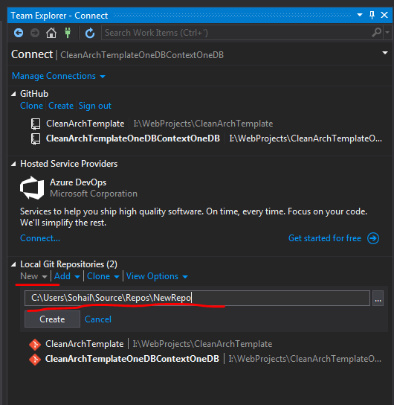

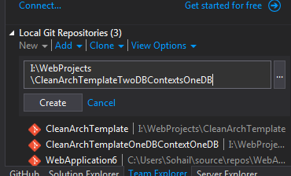

Doing so will just create 3 items in the Blank Folder

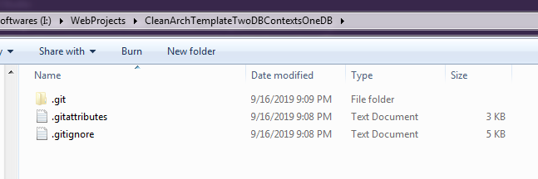

Now Copy page the Project Files, do not copy the above 3 items generated. Other wise conflict.

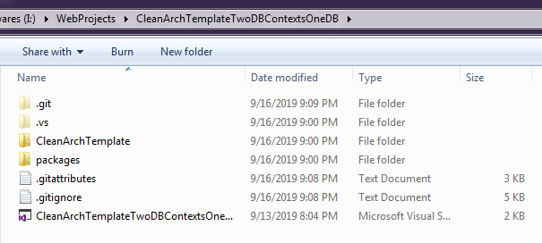

Do not change what is inside the CleanArchTemplate

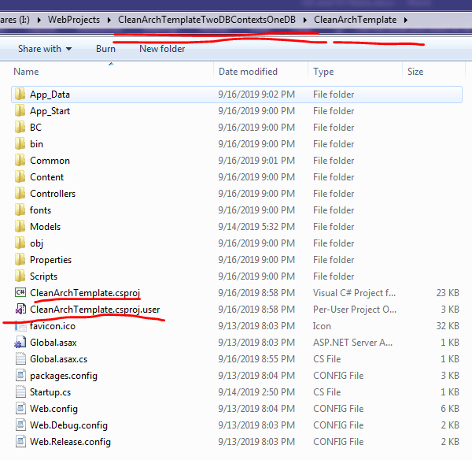

Remove the DB Files as new may have its own DB

Rename the Solution File to the Same as the root folder.

Now open project in same Visual Studio window

Now add these Files to the Local Repo First, without this it would not allow to upload the file to Git Hib

Then upload files to the Git Hub Remote Repo

Sync Option is used to update the Local and Remote Repo

Home button is used to bring the All options related to current loaded Repo

I think at one time only one repo work, because we are working on one project at one time

Project file include the Git files, that tells all about the Remote and Local Repo, Once project configured we do not have to bother about the Repos, done automatically

While Creating project we have option to add it to the Git, yet to be explored, as option tell new repo will be automatically created for the project

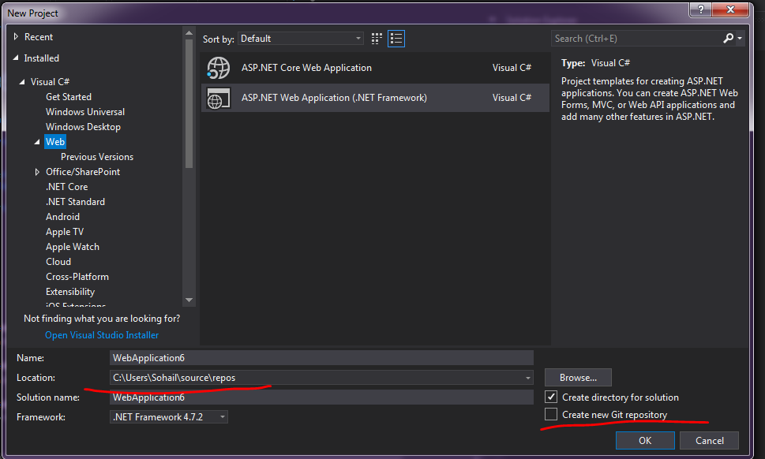

Creating new project does not add to the Remote Repo

Home Tab after Create

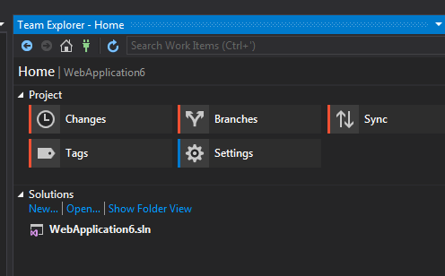

View 🡺 Team Explore opens the Tab

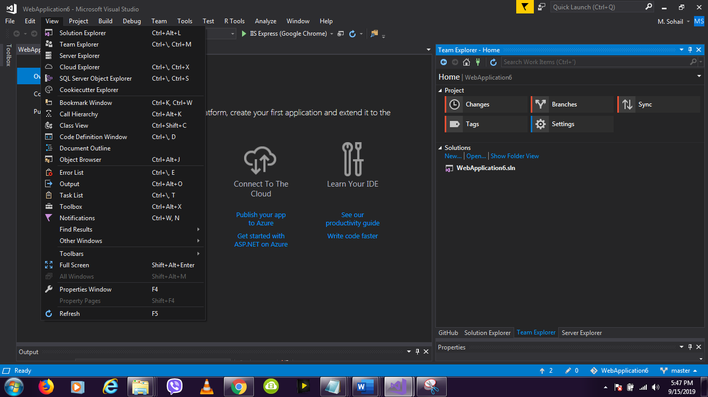

Windows 🡺 Reset Window Layout, set the VS to the original state

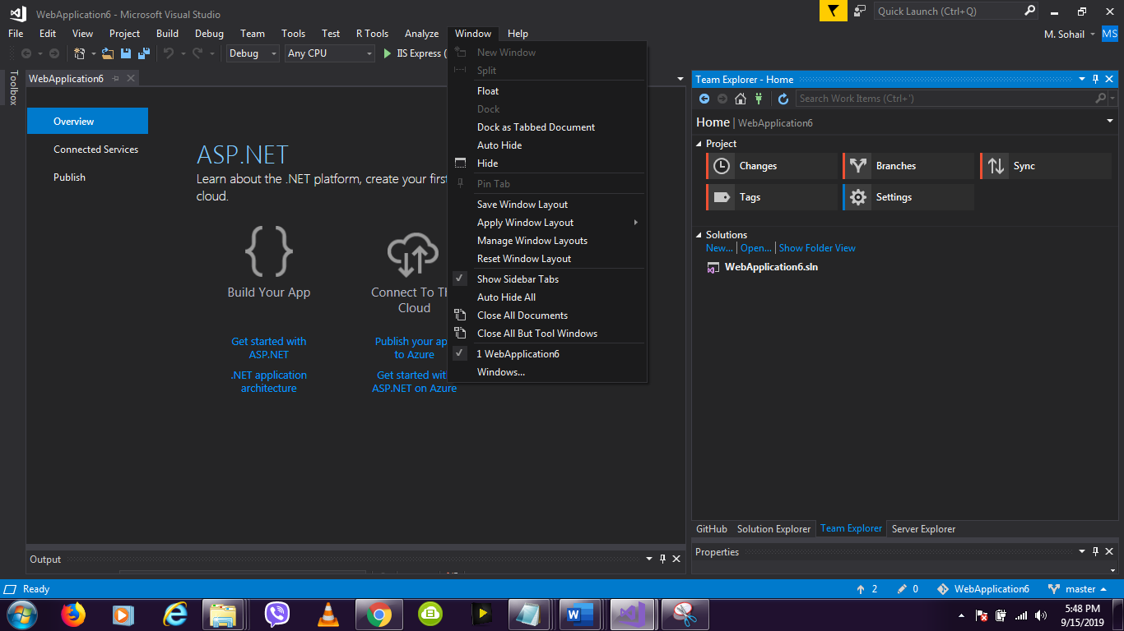

Sync button takes up to this tab, clicking middle button will only create Repo folder on the Remote Git hub, last option I do not know

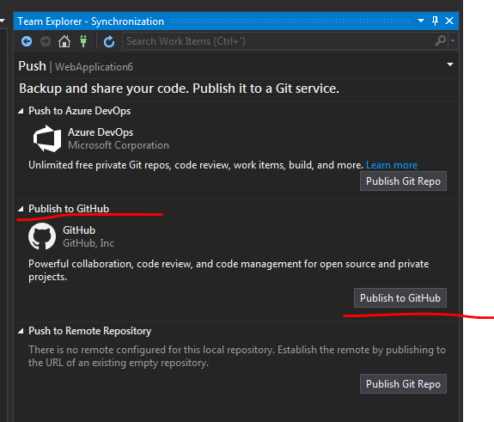

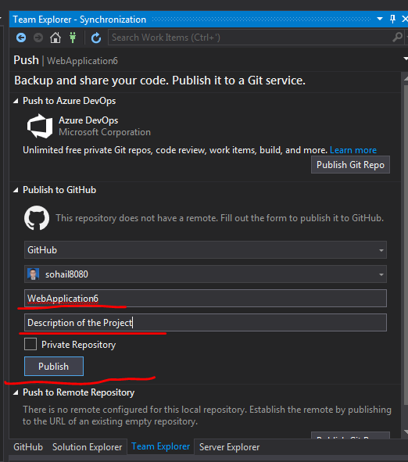

Directory published, Code is not published yed, this will only create the Directory on the GitHub

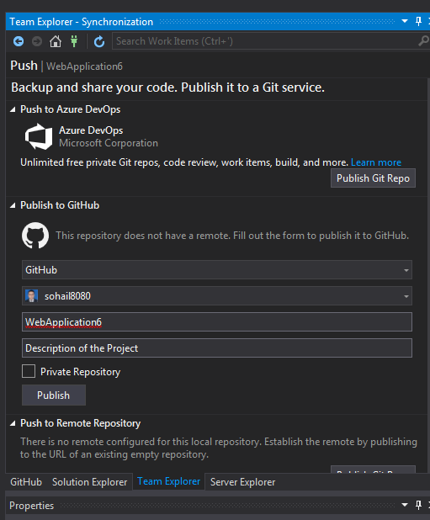

Blank Repo Directory created on the Git, for this new project, Files yet to be uploaded. We need to sync again to upload files to Git Hub

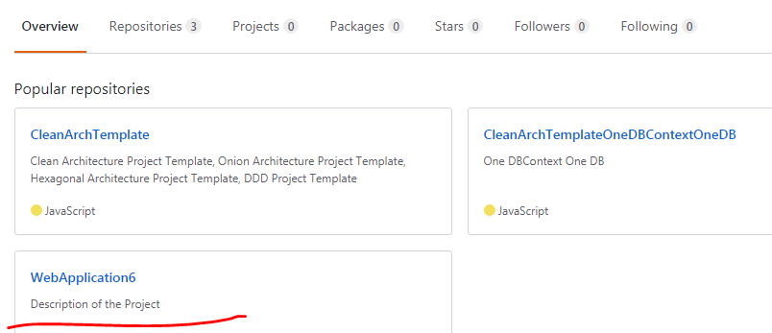

But the Repo is blank, no files there. Only folder created.

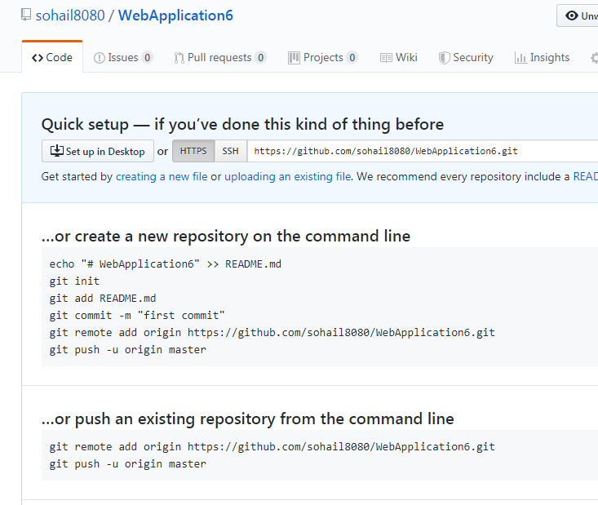

Uploading Changes to the Git Hub, will be not working as only the Folder is created files yet to uploaded. Following is Change Commit Failed.

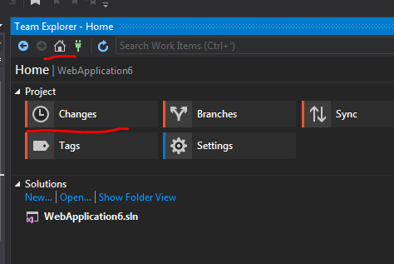

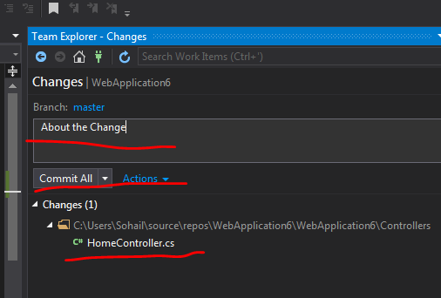

When commiting changes to the GitHUb, it tells, that Commit is done locally. You need to sync to upload it to the Git Hub.

So Commit is done on two sides, locally and remote. Local done but Remote failed.

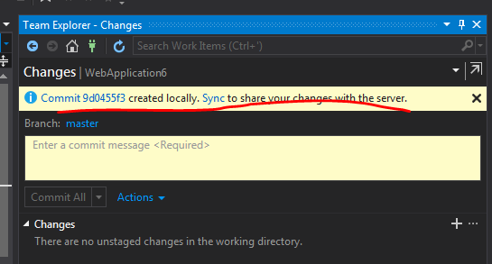

Click this link to sync



Go to Sych tab by clicking above link or by Home 🡺 Sync

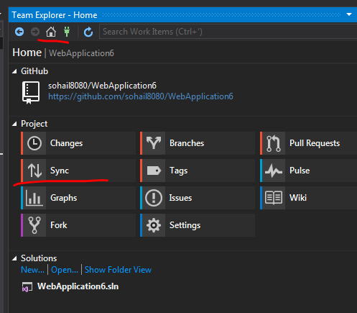

Now Sycn tab changes

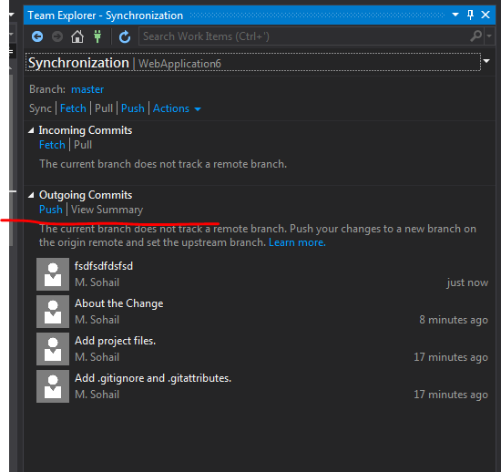

Now push will upload files to the GitHub

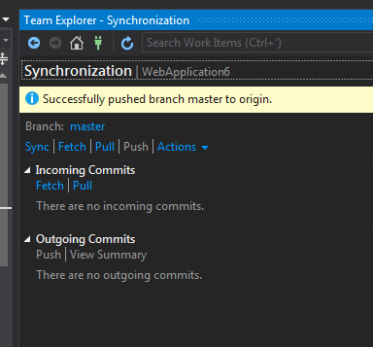

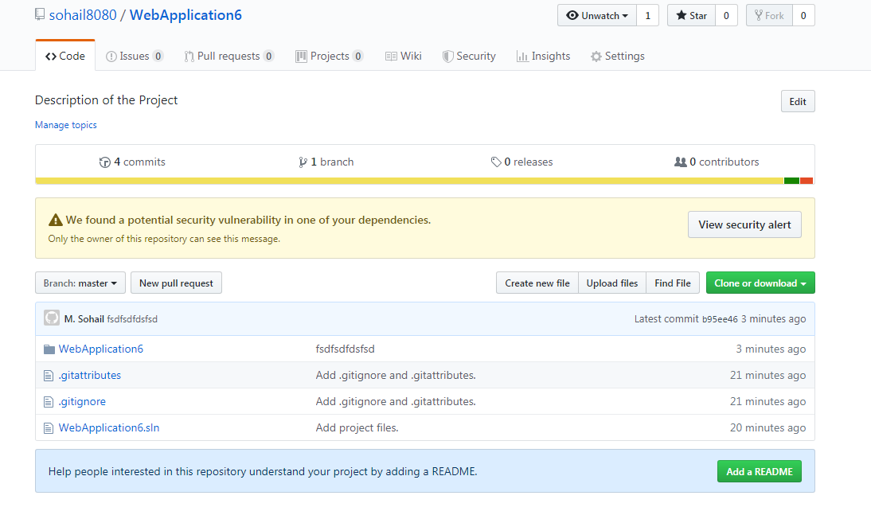

Deleting Repo on the Git hub

<https://github.com/sohail8080/WebApplication6/settings>

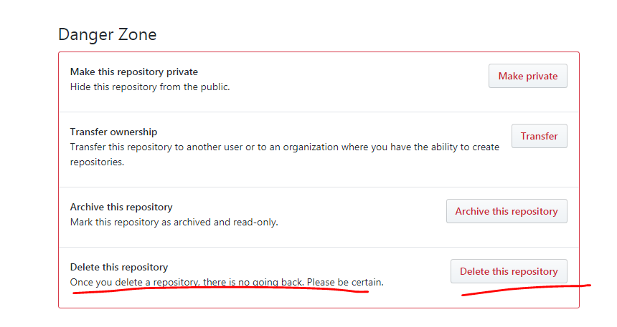

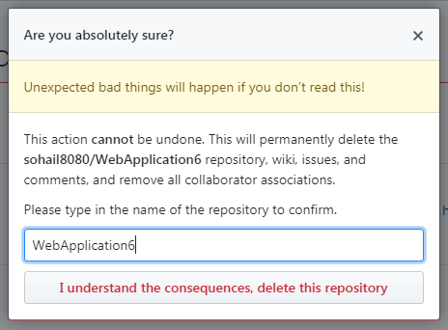

Show all files to include the Files to be included in the Source Control

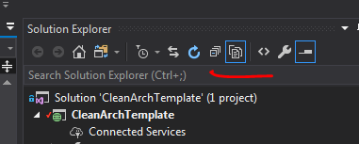

Right Click and Add DB Files and other Files to the source control

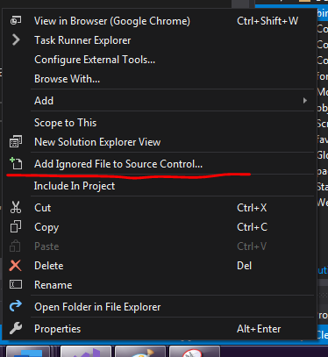

Team Explorer 🡺 Home 🡺 Changes will bring us to this dialog

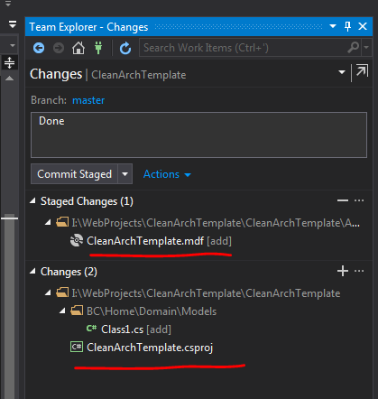

In above screen, Commit Staged is selected, it update the local and GitHub in two steps, if you want to do it in one step use the following , Commit All and Sync

